Name: Umamah Hussain

Roll-Number: 21L-1858

BSCS-5C

**Task 4:**

**Tables for Reference:**

**Patients:**

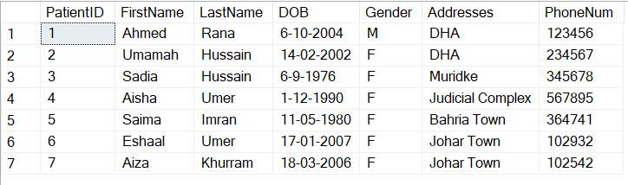

**Doctors:**

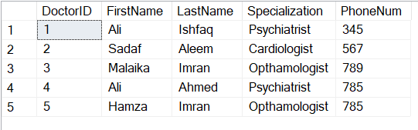

**Appointments:**

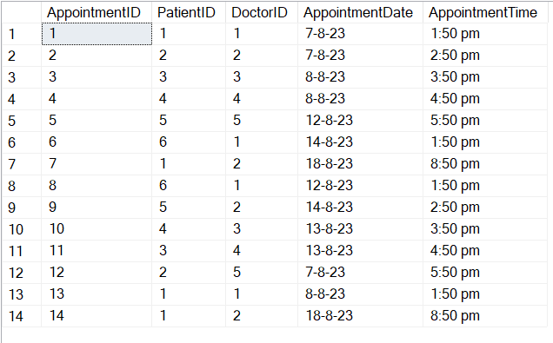

**Medical Records:**

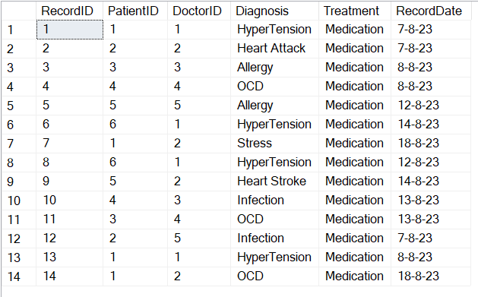

**--Find the total number of appointments for each doctor**

select A.DoctorID, concat(D.FirstName, ' ', D.LastName) as DoctorName, count(*) as TotalAppointments

from Appointments A

inner join Doctors D on A.DoctorID=D.DoctorID

group by A.DoctorID, concat(D.FirstName, ' ', D.LastName)

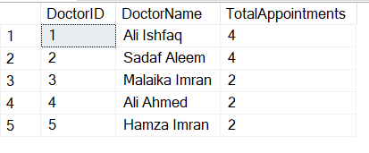

**--Retrieve a list of doctors and their specializations, along with the number of patients they have seen.**

select A.DoctorID, concat(D.FirstName, ' ', D.LastName) as DoctorName, D.Specialization, count(*) as TotalAppointments

from Appointments A

inner join Doctors D on A.DoctorID=D.DoctorID

group by A.DoctorID, D.Specialization, concat(D.FirstName, ' ', D.LastName) 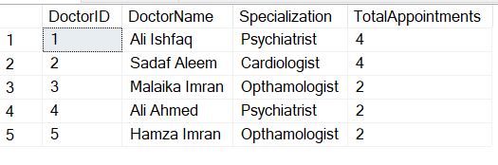

**--Find the average age of patients who have visited each doctor**

select A.DoctorID, concat(D.FirstName,' ',D.LastName) as DoctorName, count(*) as TotalPatients, avg(datediff(year, P.DOB, getdate())) as AverageAge

from Doctors D, Patients P, Appointments A

where A.DoctorID=D.DoctorID and A.PatientID=P.PatientID

group by A.DoctorID, concat(D.FirstName,' ',D.LastName)

order by A.DoctorID asc

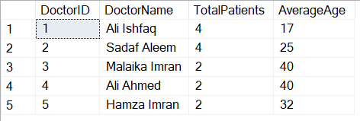

**--Find patients who have the same diagnosis from the same doctor and list their names along with the common diagnosis.**

select

M.DoctorID, concat(D.FirstName,' ',D.LastName) as DoctorName,

concat(P.FirstName,' ',P.LastName) as PatientName, M.Diagnosis

from MedicalRecords M

inner join Doctors D on M.DoctorID=D.DoctorID

inner join Patients P on P.PatientID=M.PatientID

group by M.DoctorID,M.Diagnosis, concat(D.FirstName,' ',D.LastName), concat(P.FirstName,' ',P.LastName)

having count(*) > 1;

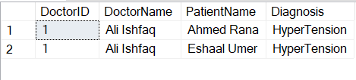

**--Retrieve the top 5 doctors with the highest number of appointments**

select Top(5) A.DoctorID, concat(D.FirstName, ' ', D.LastName) as DoctorName, count(*) as TotalAppointments

from Appointments A

inner join Doctors D on A.DoctorID=D.DoctorID

group by A.DoctorID, concat(D.FirstName, ' ', D.LastName)

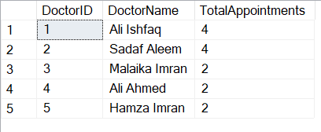

**--Find the total number of appointments for each patient who has had more than 3 appointments, and list them in ascending order of appointment count**

select A.PatientID, concat(P.FirstName,' ',P.LastName) as PatientName, count(*) as TotalAppointments

from Appointments A

inner join Patients P on P.PatientID=A.PatientID

group by A.PatientID, concat(P.FirstName,' ',P.LastName)

having count(*)>3

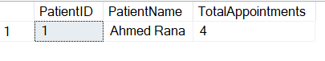

**--Retrieve the list of doctors who have seen at least 10 different patients, ordered by the number of different patients seen in descending order**

select A.DoctorID, concat(D.FirstName, ' ', D.LastName) as DoctorName,count(*) as DiffPatients

from Appointments A

inner join Doctors D on A.DoctorID=D.DoctorID

group by A.DoctorID, concat(D.FirstName, ' ', D.LastName)

having count(distinct A.PatientID)>=10

order by DiffPatients desc

